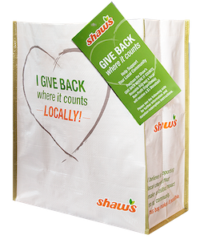

GIVE BACK WHERE IT COUNTS REUSABLE BAG PROGRAM

Press Release
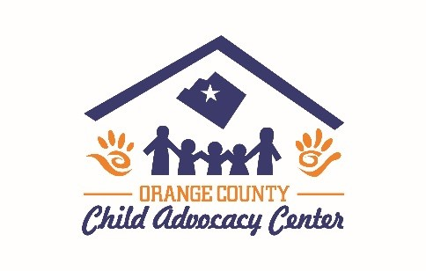
FOR IMMEDIATE RELEASE: Orange County Child Advocacy Center, Chelsea Vermont

Orange County Child Advocacy Center Celebrates Selection as a Shaw’s GIVE BACK WHERE IT COUNTS Reusable Bag Program Beneficiary

Orange County Child Advocacy Center has been selected as a beneficiary of the Shaw’s GIVE BACK WHERE IT COUNTS Reusable Bag Program for the month of December.

The Shaw’s GIVE BACK WHERE IT COUNTS Reusable Bag Program, which launched in March 2019, is a reusable bag program that facilitates community support with the goal to make a difference in the communities where shoppers live and work.

Orange County Child Advocacy Center was selected as the December beneficiary of the program by store leadership at the Shaw’s located at the Randolph, Vermont location. Orange County Child Advocacy Center will receive a $1 donation every time the $3.00 GIVE BACK WHERE IT COUNTS Reusable Bag is purchased at this location during December, unless otherwise directed by the customer through the Giving Tag attached to the bag.

“We are so honored to have been selected and we are excited to participate in the Give Back Where it Counts Reusable bag program!” said Michele Thurston, Program Coordinator of Orange County Child Advocacy Center. “This donation will help us provide trauma centered coordinated care services to victims and their families.”

Orange County Child Advocacy Center is a nonprofit based in Orange County, Vermont, Orange County Child Advocacy Center has been providing services to child and adult victims of sexual abuse and severe physical abuse for several years now. Learn more about Orange County Child Advocacy Center by visiting www.OrangeCountyCAC.org.

For more information on the Shaw’s GIVE BACK WHERE IT COUNTS Reusable Bag Program, visit shaws.2givelocal.com.

shaws.2givelocal.com

